**Project Scenario**

Mint Classics Company, a retailer of classic model cars and other vehicles, is looking at closing one of their storage facilities.

To support a data-based business decision, they are looking for suggestions and recommendations for reorganizing or reducing inventory, while still maintaining timely service to their customers. For example, they would like to be able to ship a product to a customer within 24 hours of the order being placed.

As a data analyst, you have been asked to use MySQL Workbench to familiarize yourself with the general business by examining the current data. You will be provided with a data model and sample data tables to review. You will then need to isolate and identify those parts of the data that could be useful in deciding how to reduce inventory. You will write queries to answer questions like these:

1) Where are items stored and if they were rearranged, could a warehouse be eliminated?

2) How are inventory numbers related to sales figures? Do the inventory counts seem appropriate for each item?

3) Are we storing items that are not moving? Are any items candidates for being dropped from the product line?

The answers to questions like those should help you to formulate suggestions and recommendations for reducing inventory with the goal of closing one of the storage facilities.

**Project Objectives**

1. Explore products currently in inventory.

2. Determine important factors that may influence inventory reorganization/reduction.

3. Provide analytic insights and data-driven recommendations.

**Your Challenge**

Your challenge will be to conduct an exploratory data analysis to investigate if there are any patterns or themes that may influence the reduction or reorganization of inventory in the Mint Classics storage facilities. To do this, you will import the database and then analyse data. You will also pose questions, and seek to answer them meaningfully using SQL queries to retrieve data from the database provided.

In this project, we'll use the fictional Mint Classics relational database and a relational data model. Both will be provided.

After you perform your analysis, you will share your findings.

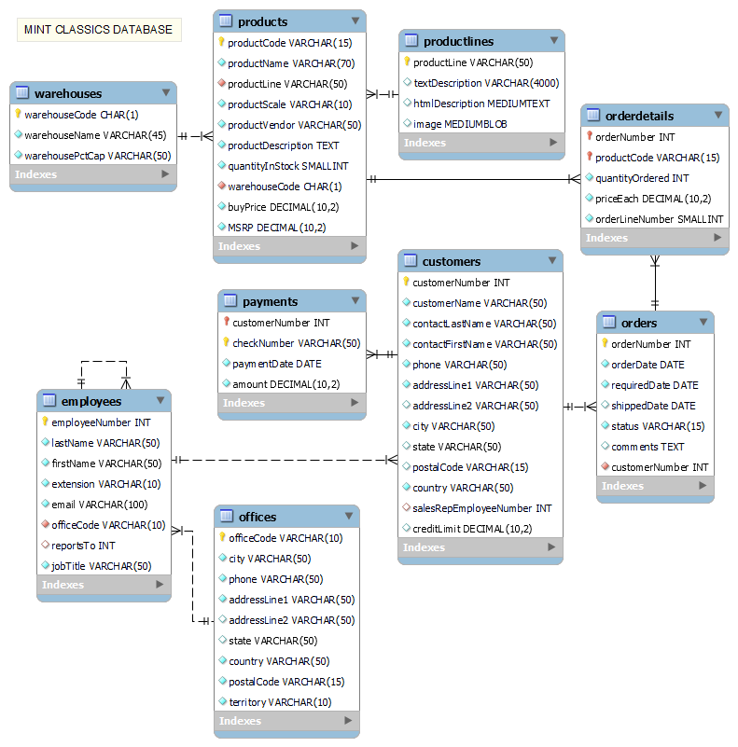

After a comprehensive SQL analysis, I have derived the following for Mint Classics:

(I will be assuming that the monetary unit here is dollars ($))

Total quantity in stock – 555131, Breakdown according to product line –

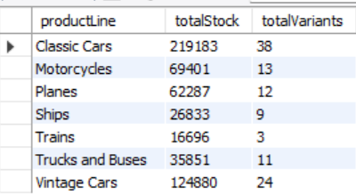

Breakdown according to warehouses (for warehouse a, motorcycles is also included and for warehouse d ships and trains are also included)

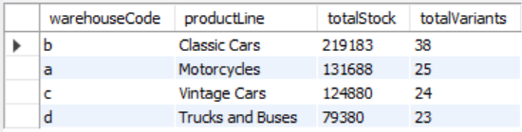

Total amount of products offered – 110

FOR TOTAL ORDERS, stock vs quantity

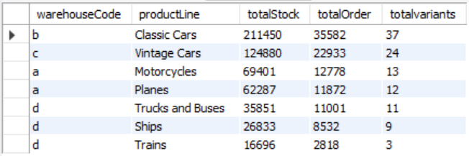

From this table and the total quantity of stock table we can see that one classic car variant has not been sold, at all, 1985 Toyota Supra with total quantity of 7733. We will be completely destocking it

|  |
| --- |
|  |

Total quantity ordered – 1,05,516

Total Sales- $96,04,190.61

Data timeframe- 6 January 2003 to 31 May 2005 – 876 days- 2.4 Years approx

**Stock(highest to lowest) vs profit**

#highest -

# 2002 Suzuki XREO Motorcycles 9997 1028

# 1995 Honda Civic Classic Cars 9772 917

# America West Airlines B757-200 Planes 9653 984

# 2002 Chevy Corvette Classic Cars 9446 894

# 1932 Model A Ford J-Coupe Vintage Cars 9354 957

#Lowest-

# Pont Yacht Ships 414 958

# 1997 BMW F650 ST Motorcycles 178 1014

# 1928 Ford Phaeton Deluxe Vintage Cars 136 972

# 1968 Ford Mustang Classic Cars 68 933

# 1960 BSA Gold Star DBD34 Motorcycles 15 1015

**Profit per piece**

#highest

# 1952 Alpine Renault 1300 Classic Cars 7305 115.72

# 2001 Ferrari Enzo Classic Cars 3619 112.21

# 2003 Harley-Davidson Eagle Drag Bike Motorcycles 5582 102.64

# 1968 Ford Mustang Classic Cars 68 99.23

# 1928 Mercedes-Benz SSK Vintage Cars 548 96.19

#lowest

# 1936 Mercedes Benz 500k Roadster Vintage Cars 2081 19.28

# Boeing X-32A JSF Planes 4857 16.89

# 1930 Buick Marquette Phaeton Vintage Cars 7062 16.58

# 1982 Ducati 996 R Motorcycles 9214 16.09

# 1939 Chevrolet Deluxe Coupe Vintage Cars 7332 10.62

**Highest and lowest selling product vs profit earned with it**

#highest order-

# 1992 Ferrari 360 Spider red Classic Cars 1808 135996.78

# 1937 Lincoln Berline Vintage Cars 1111 35214.70

# American Airlines: MD-11S Planes 1085 32400.98

# 1941 Chevrolet Special Deluxe Cabriolet Vintage Cars 1076 33049.37

# 1930 Buick Marquette Phaeton Vintage Cars 1074 12536.80

#lowest order-

# 1999 Indy 500 Monte Carlo SS Classic Cars 855 52240.32

# 1911 Ford Town Car Vintage Cars 832 17601.17

# 1936 Mercedes Benz 500k Roadster Vintage Cars 824 11841.39

# 1970 Chevy Chevelle SS 454 Classic Cars 803 13696.95

# 1957 Ford Thunderbird Classic Cars 767 23862.50

**True profit high to low vs total quantity ordered**

#highest

# 1992 Ferrari 360 Spider red Classic Cars 1808 135996.78

# 1952 Alpine Renault 1300 Classic Cars 961 95282.58

# 2001 Ferrari Enzo Classic Cars 1019 93349.65

# 2003 Harley-Davidson Eagle Drag Bike Motorcycles 985 81031.30

# 1968 Ford Mustang Classic Cars 933 72579.26

#lowest

# 1930 Buick Marquette Phaeton Vintage Cars 1074 12536.80

# 1936 Mercedes Benz 500k Roadster Vintage Cars 824 11841.39

# 1982 Ducati 996 R Motorcycles 906 11397.92

# Boeing X-32A JSF Planes 960 11233.33

# 1939 Chevrolet Deluxe Coupe Vintage Cars 937 6904.85

Classic cars being the most stocked corresponds to it also being the ones which are the most sold, followed by vintage cars.

**SUGGESTIONS:**

* Particularly for 1939 Chevrolet Deluxe Coupe, it yields extremely low profit and we can completely destock it.
* Restock 1960 BSA Gold Star DBD34 and 1997 BMW F650 ST immediately if R&D suggests that there is demand.
* For Boeing X-32A JSF, we can reduce it further since the profit it yields and the orders too is not very high.
* May or May not consider restocking Pont Yacht based on R&D.

**IMPLEMENTATION AND OUTCOME:**

Amount intended to reduce - 219200 + 7733(Toyota Supra) - any further increase in stock, approximately 10000 - leaving extra space for any unforeseen circumstance, 10000 = 2,06,933

**THUS, NEW TOTAL STOCK = 555131 -206933 = 348198**

|  | **Product Line** | **Total stock** | **Final alteration** | **Final Stock** | **Warehouse** |
| --- | --- | --- | --- | --- | --- |
|  | Classic Cars | 211450 | -91700 | 119750 | B |
|  | Vintage Cars | 124880 | -50800 | 74080 | C |
|  | Motorcycles | 69401 | -31400 | 38001 | A |
|  | Planes | 62287 | -23900 | 38387 | A |
|  | Trucks and Buses | 35851 | -8500 | 27351 | D |
|  | Ships | 26833 | -5400 | 21433 | D |
|  | Trains | 16696 | -7500 | 9196 | D |

**#Warehouse D(south) can be vacated and trucks and buses + ships + trains can be transferred to warehouse A (north)**

**CONCLUSION**

Given business task – ‘suggestions and recommendations for reorganizing or reducing inventory, while still maintaining timely service to their customers’ has been fulfilled.

Warehouse D(South) can be vacated and trucks and buses + ships + trains can be transferred to warehouse A (North), thus leaving Mint Classics with three (3) functional warehouses.

NEW SETUP –

A - Motorcycles, planes, ships, trains, trucks and buses

B – Classic Cars

C – Vintage Cars

New total stock – 348198.